**Graphic Processing**



**Project Documentation**

**Vaida Diana-Laura**

**Group 30433**

**3rd year**

**Computer Science**

**Assistant Teacher: Victor Ioan Bâcu**

**Content of the project documentation:**

1. Contents  
2. Subject specification  
3. Scenario  
    3.1. scene and objects description  
    3.2. functionalities  
4. Implementation details  
    4.1. functions and special algorithms  
           4.1.1. possible solutions  
           4.1.2. the motivation of the chosen approach  
    4.2. graphics model  
    4.3. data structures  
    4.4. class hierarchy  
5. Graphical user interface presentation / user manual  
6. Conclusions and further developments  
7. References

# **Subject Specification**

The objective of this project is to craft a lifelike scene featuring a variety of 3D objects, employing the OpenGL library. Users will engage with the application through mouse and keyboard interactions. The depicted setting portrays a countryside vacation house.

**Scenario**

**Scene and objects description**

The depicted setting emulates a rural environment, featuring a vacation house, a table with fruits, a cat, and a fence with roses.

## **Functionalities**

The movement through the scene is made by using the keys W, A, S, D, Q, E, R, F and the mouse for rotation. O,L move the light around the scene. Also, by using the key 1,2,3 show the solid, wireframe, polygonal surfaces.

**Implementation Details**

## **Functions and Special Algorithms**

Possible solutions

The OpenGL library encompasses a diverse range of functions, including but not limited to:

* “glViewport(...)” for configuring the Viewport transform.
* “glfwCreateWindow(...)” for window creation.
* “glGenTextures(...)”
* “glBindTexture(...)”
* “glTexImage2D(...)” for depth texture creation within Framebuffer objects.
* Numerous others.

In this project, a crucial function employed is “void renderScene()”. This function is responsible for transmitting data to the shaders, computing values, creating models, calculating normal matrices, and handling rotation, translation, and scaling operations.

Inside this function are called the ones specifically oriented on the object. Each 3D model has its own render function, the differences being observed at the objects which are part of an animation.

The function “void initUniforms()”, with its variants “void initLampUniforms()” and “void initPunctiformUniforms()” are responsible for details about the light, specifically, the directional light and point light.

The function “void initShaders()” instantiates shaders, contributing to the rendering pipeline.

Furthermore, the function `void initModels()` initializes all 3D models within the scene.

Several other essential functions include:

* “void processMovement()”
* “void draw(gps::Shader shader, bool depthPass)”
* “void mouseCallback(GLFWwindow* window, double xpos, double ypos)”
* “void keyboardCallback(GLFWwindow* window, int key, int scancode, int action, int mode)”
* “void initFBO()”
* “glm::mat4 computeLightSpaceTrMatrix()”

Those functions are the ones responsible for the changes applied to the camera or to the objects in the scene.

The “void mouseCallback(GLFWwindow* window, double xpos, double ypos)” function utilizes Euler angles for camera control. In particular, the variables yaw and pitch represent the rotation angles around the vertical (y-axis) and horizontal (x-axis) axes, respectively. These angles are updated based on the mouse movement in the x and y directions.

Another important library is GLM (OpenGL Mathematics), which is a C++ mathematics library designed for computer graphics and 3D applications. It provides a collection of vector and matrix operations, along with various mathematical functions, closely mirroring the functionality of OpenGL shaders.

### **The motivation of the chosen approach**

The choice for this kind of implementation was having as starting point the laboratories from this semester, where it was discussed about rendering object, light computation, animations, different photorealistic effects. Starting from this and the core of the project, I developed some ideas that fit with the chosen theme of the project.

## **Graphics Model**

The majority of the objects in the scene are downloaded from the Internet (free3d). Exceptions are the land, lake, sky and some minor components. All the objects were imported to the Blender, where they were placed, scaled, rotated, texturized. While some objects had existing textures, many lacked them or required modification (separate by texture, group components) for better integration into OpenGL. For the terrain, I manually sculpted the hills and the lake into a plane using Blender's tools. The sky is a textured part of a sphere (approximatively 1/3), which covers the plane. To be able to see the pattern, I had to flip the normal in the sphere.

The most time-consuming aspect involved selecting suitable coordinates and exercising creativity to craft a scene from scratch.

## **Data Structures**

Window Class (Window.h):

Represents the application window.

Manages window creation, resizing, and callbacks.

Utilizes GLFW for window management.

Shader Class (Shader.hpp):

Manages OpenGL shader programs.

Handles loading, compiling, linking, and setting uniform variables.

Encapsulates vertex and fragment shaders.

Camera Class (Camera.hpp):

Represents a 3D camera in the scene.

Manages camera position, orientation, and movement.

Provides functions for generating view matrices.

Model3D Class (Model3D.hpp):

Represents a 3D model in the scene.

Handles loading and rendering of 3D models.

Specific instances include cube, screenQuad, scene, and fish models.

glm Library:

Provides OpenGL Mathematics functionality.

Includes data structures like glm::mat4 for 4x4 matrices, glm::mat3 for 3x3 matrices, and glm::vec3 for 3D vectors.

Supports various mathematical operations, transformations, and utilities for OpenGL applications.

OpenGL Constants and Functions:

Utilizes OpenGL constants such as GL_TRIANGLES, GL_FRONT_AND_BACK, etc.

Calls OpenGL functions like glClearColor, glUseProgram, glUniformMatrix4fv, etc.

Manages OpenGL-related operations, framebuffer objects (FBOs), textures, and rendering.

## **Class Hierarchy**

Beside the most important file, “main.cpp”, where lies the majority of the code, there are also some useful classes:

* Camera: contains the implementation for camera movement (up, down, front, back, left, right, rotate)
* Mesh: represents a 3D object; includes the following data structures:
* Vertex (position, normal vector and texture coordinates)
* Texture (id, type and path)
* Material
* Model3D: contains methods for printing meshes using a specified shader program
* Shader: contains methods needed to import shader programs
* Window: used for the creation of the visualization window

**Graphical user interface presentation / user manual**

1-viewing solid surfaces

2-viewing wireframe surfaces

3-viewing polygonal surfaces

W-move camera forward

S-move camera backward

A-move camera to the left

D-move camera to the right

Q-rotate camera to the right

E-rotate camera to the left

R-move camera up

F-move camera down

O-move the source of light to the left

U-move the source of light to the right

M-show the depth map

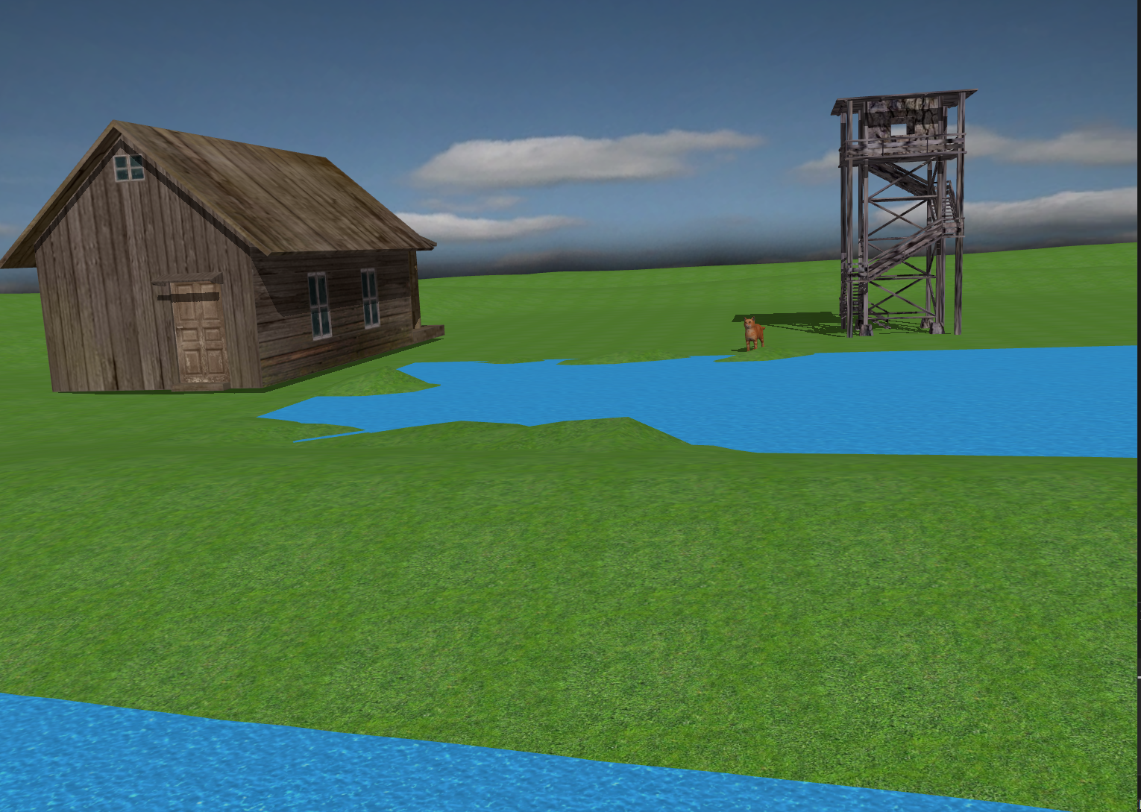

The shadow applied to the cat, farmhouse and watchtower

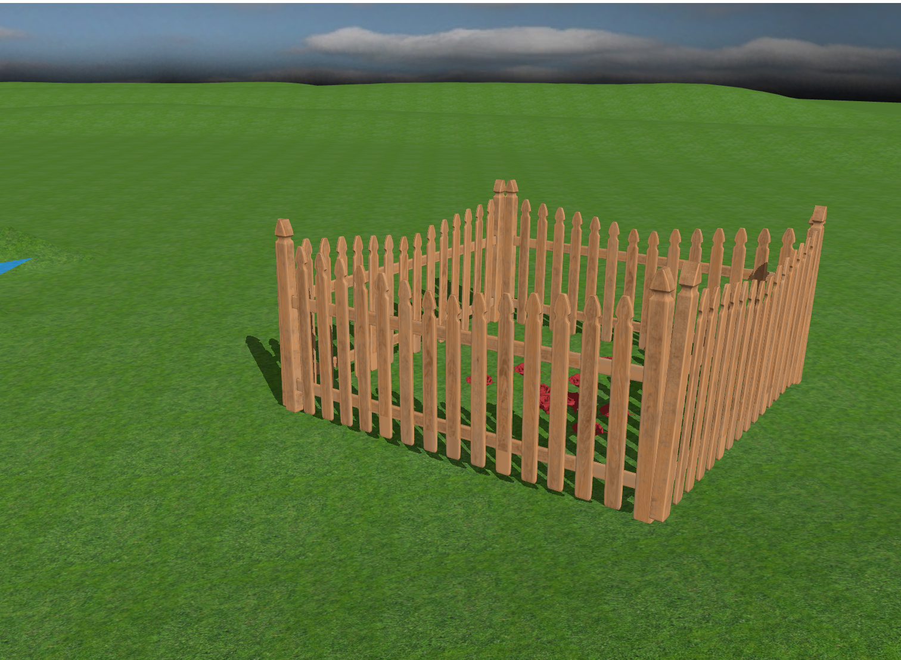

The fence with the roses

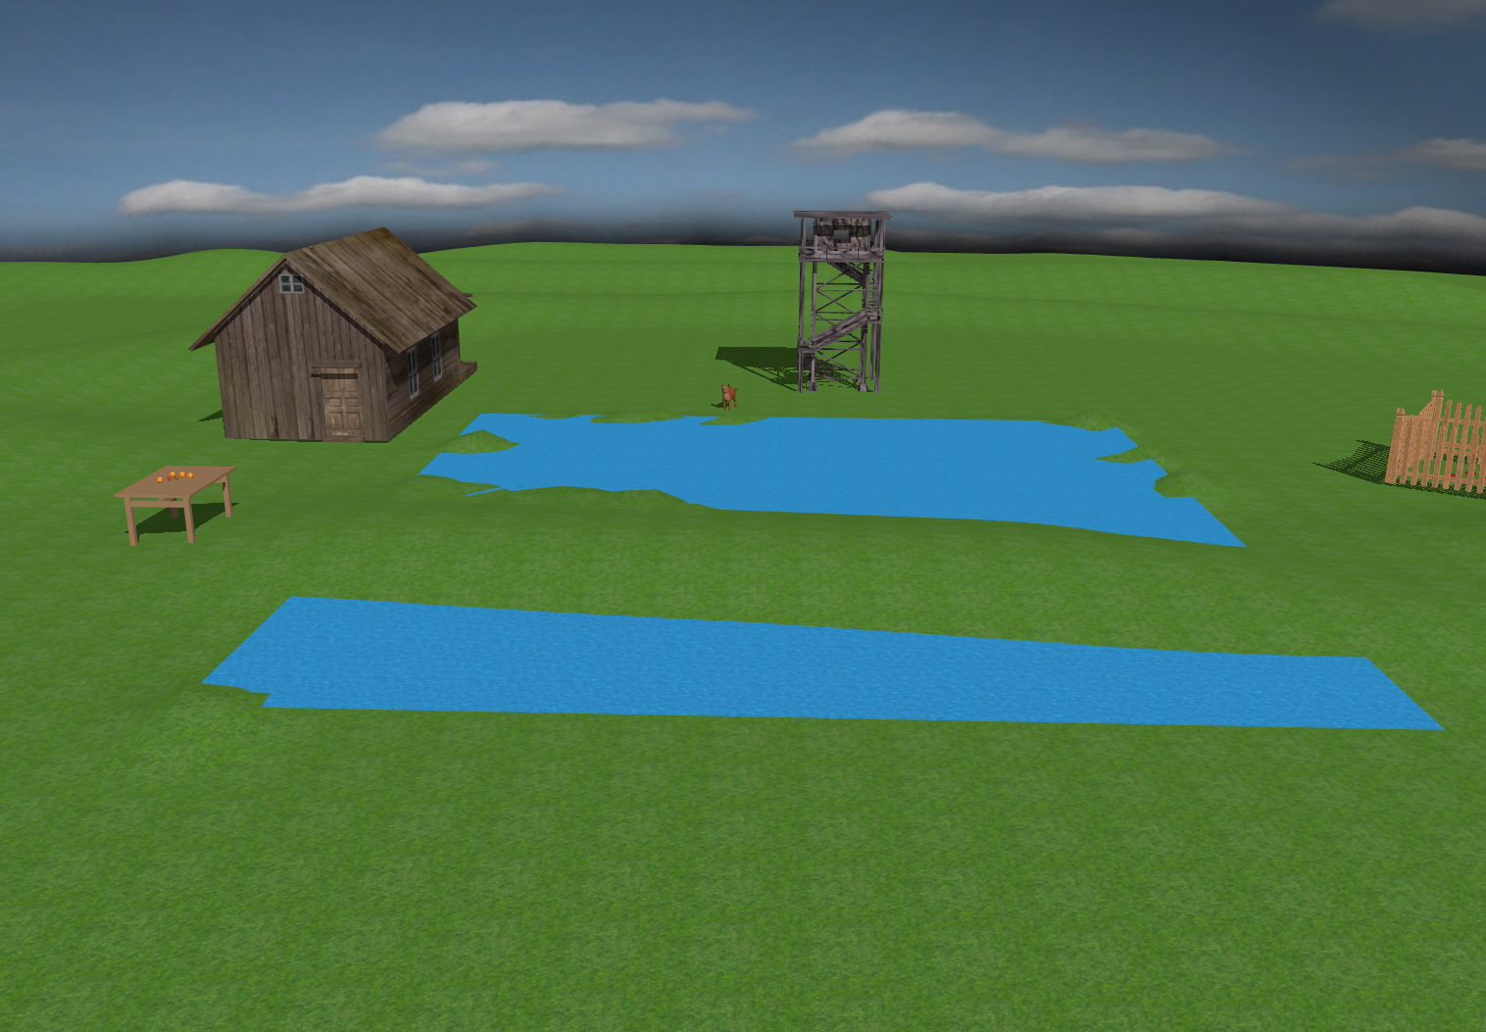

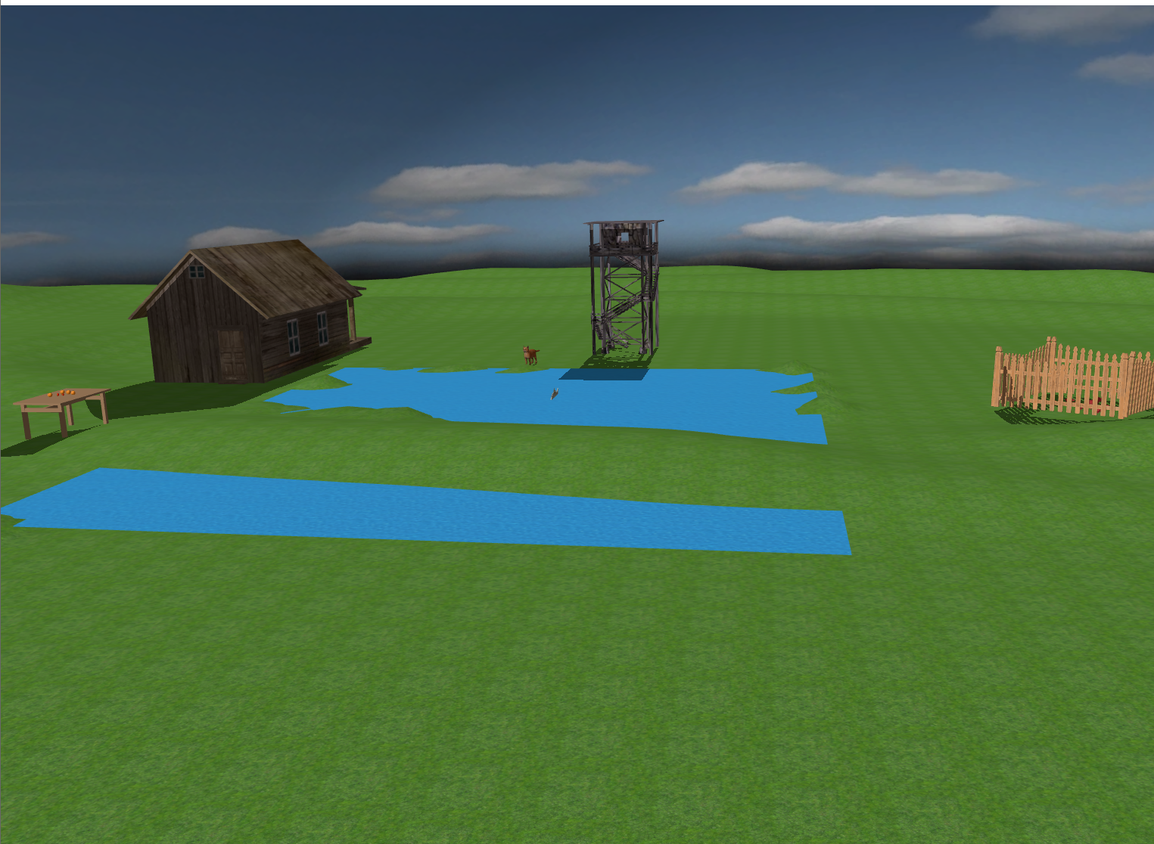

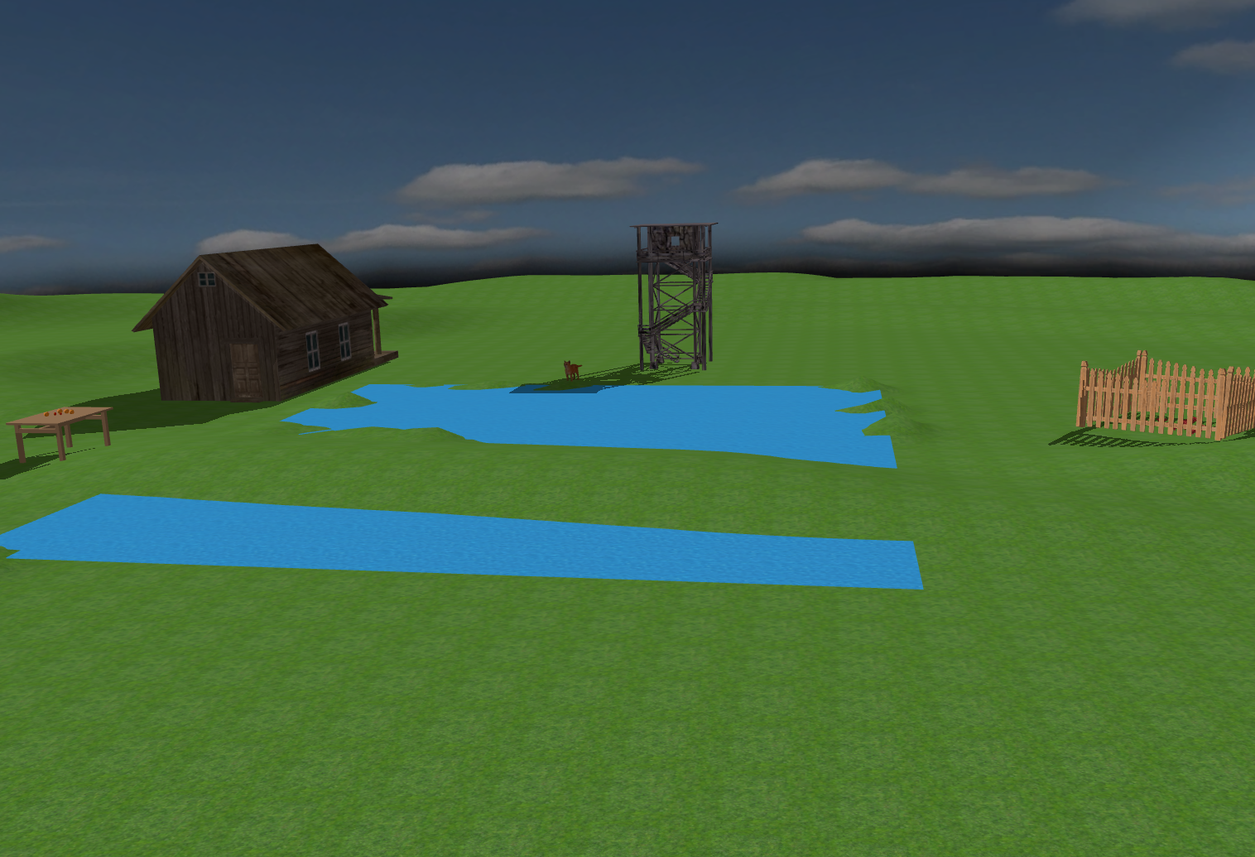

The light source moving through the scene

Animation of the fish going up and down in the water

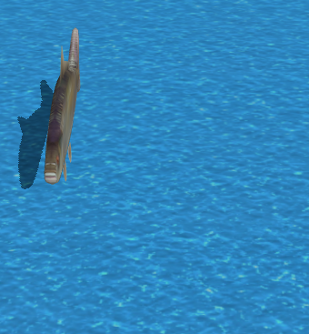\

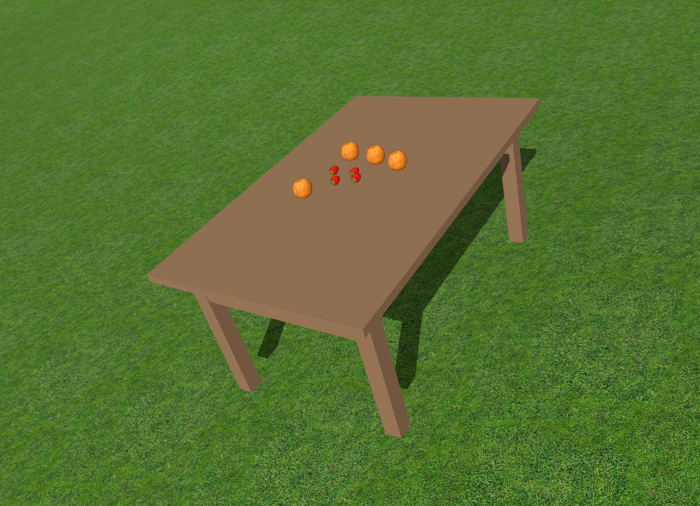

The table with the strawberries and apples

**Conclusions and further developments**

In summary, this project involved working with two programs: Microsoft Visual Studio and Blender, the latter being a new experience for me.

Coding was the hardest part, even though we had laboratories as the starting point. For further developments, I have the following ideas:

* Adding more lights
* New animations
* Weather: rain, fog, snow
* Adding day and night

**References**

1. “Camera”, “<https://learnopengl.com/Getting-started/Camera>”
2. “OpenGL”, “<https://en.wikipedia.org/wiki/OpenGL>”
3. “OpenGL Mathematics (GLM)”, “<https://www.opengl.org/sdk/libs/GLM/>”
4. “Free3D”, “<https://free3d.com/>”
5. “Tutoriale Blender”, “<https://www.youtube.com/playlist?list=PLrgcDEgRZ_kndoWmRkAK4Y7ToJdOf-OSM>”

6. https://www.youtube.com/watch?v=W3gAzLwfIP0&list=PLlrATfBNZ98foTJPJ_Ev03o2oq3-GGOS2&index=3